IoT HOME AUTOMATION

* Home Automation has always been a fascinating thing for me .Sometimes when we are settled in couch we might forgot to switch off some lights in some other room or might remember we have to turn on washing machine or heat food just when movie is about to complete or turn on water motor
* Wonderful if we can do these tasks without moving using mobiles or any electronic device. There are lot of home automation gadgets available, but I can’t afford them. My aim in this project is to build a low cost version of it



[This Photo](https://opensource.com/article/17/4/5-projects-raspberry-pi-home) by Unknown Author is licensed under [CC BY-SA](https://creativecommons.org/licenses/by-sa/3.0/)

User Perspective:

* User can control any home appliance using any electronic gadgets like mobiles, laptops, Smart Tvs using a webpage in browser.

Designer Perspective:

* This project contains any Wi-Fi module which receives request from users through webpage, microcontroller for processing requests, relay modules to control high current devices through microcontroller and some wires to connect

Constraints:

* Microcontroller should have enough GPIO pins to control all home appliances
* Wi-Fi module should have enough range and speed of transfer to connect to Home Wi-Fi without any problem and receive requests smoothly
* Microcontroller and Wi-Fi module should be budget friendly as we are building low cost version
* Microcontroller and Wi-Fi module should not consume too much power

System Options

I have considered the following system options:

* RASPBERRY PI 4
* ESP32
* ARDUINO + ESP8266 WiFi MODULE
* NODEMCU

RASPBERRY PI 4:

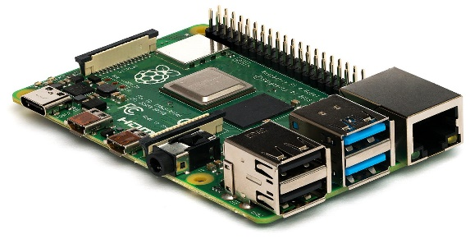

[This Photo](https://en.wikipedia.org/wiki/Raspberry_Pi) by Unknown Author is licensed under [CC BY-SA](https://creativecommons.org/licenses/by-sa/3.0/)

It has Arm cortex A-72 Processor and in-built Bluetooth and WiFi module. It even has an operating system. It is over specified for my need because I don’t need A-72 processor for simple requests, I don’t need Bluetooth as I am using web requests and the price is too high($35-$85) for my need

ESP 32 DEV BOARD:

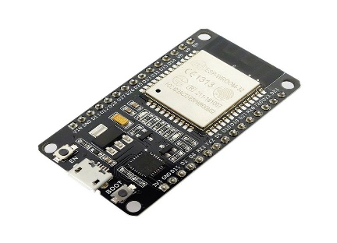

[This Photo](http://www.electronics-lab.com/project/esp32-webserver-tutorial/) by Unknown Author is licensed under [CC BY-SA](https://creativecommons.org/licenses/by-sa/3.0/)

This is one of the best options I have seen. It has good powerful microcontroller with integrated WiFi and Bluetooth and Digital to Analog converter which is very useful for driving devices like fans, but it has Bluetooth which I don’t use and currently it’s not available for me. It’s also a bit expensive ($17) There are other cheaper options So I ruled out this.

ARDUINO+ESP8266 MODULE:

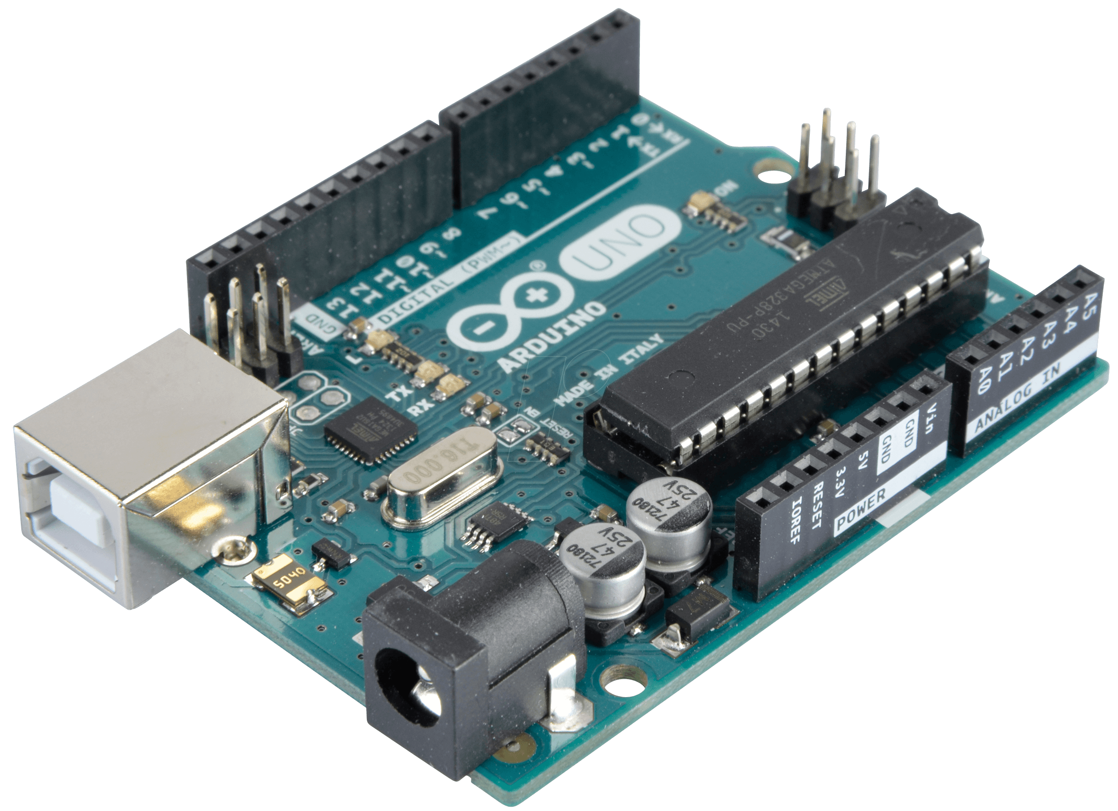

[This Photo](https://www.teachmemicro.com/beaglebone-black-serial-arduino/) by Unknown Author is licensed under [CC BY-NC](https://creativecommons.org/licenses/by-nc/3.0/)

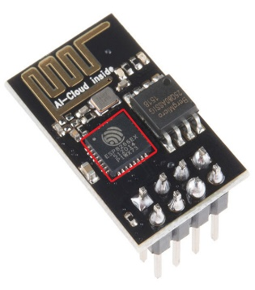

[This Photo](https://arduino.stackexchange.com/questions/51683/camera-on-mkr1000-or-nodemcu-0-9) by Unknown Author is licensed under [CC BY-SA](https://creativecommons.org/licenses/by-sa/3.0/)

Arduino uses Atmega328p microcontroller which is sufficient for my need. In this model esp 8266 Wi-Fi module is used to accept web requests from devices. The problems with this model is space problem. It costs around ($12+$4=$16).I want to make it even cheaper if possible and reduce space so I ruled this out.

NODEMCU:

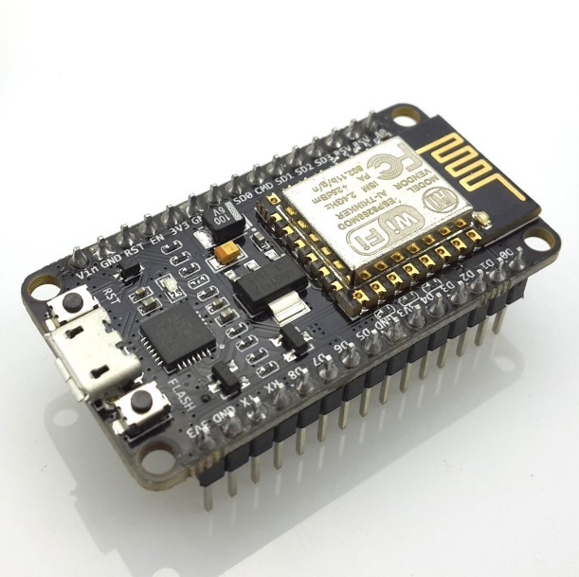

[This Photo](https://www.teachmemicro.com/intro-nodemcu-arduino/) by Unknown Author is licensed under [CC BY-NC](https://creativecommons.org/licenses/by-nc/3.0/)

This also has a 32-bit microcontroller and esp8266 module. For my need it functions equivalent to Arduino+esp8266 but it costs only $4.5.This is the cheapest version I could find which can be programmed using Arduino IDE and has inbuilt WiFi network connectivity. It’s also available to me even during this period of covid-19. So I chose nodemcu to do home automation

TESTING INDIVIDUAL COMPONENTS  
 AND INTEGRATION OF COMPONENTS

These are the steps I followed:

* First, I have checked the continuity of all jumper wires using multi-meter
* Before Directly operating with AC appliances I want to use LEDs as actuators for my project
* Then I have installed ESP8266 Library in my Arduino IDE.I have connected nodemcu to my computer using USB cable
* I started with connecting my nodemcu to internet and setting up a server on it, then it waits for client to connect that is it keeps listening on port 80.
* I tried to connect one led first and control it using web request using a mobile, then extended it to 4 LEDs (just by changing number you can extend it to 16 appliances)

This is final arrangement with leds

This is link for working video of this: <https://drive.google.com/file/d/1jLGIIvynQauMxuHoXd3yMAIcR5sK8OEC/view?usp=sharing>

THANK YOU